Coincidental Cohesion

📌 Definition:
# Source: AI Source: Provided by: [Data Path: Persons Table -> ID Column: 1, Name_En Column: Motasem Essam] -> From: [Chatgpt (GPT‑5 Mini)] on [12/9/2025]
Coincidental Cohesion occurs when elements of a class/module are grouped arbitrarily, with no meaningful relationship between them.

🧠 Simple idea:
# Source: AI Source: Provided by: [Data Path: Persons Table -> ID Column: 1, Name_En Column: Motasem Essam] -> From: [Chatgpt (GPT‑5 Mini)] on [12/9/2025]
“Everything thrown together randomly” ⚠️

🔍 Key characteristics:
# Source: AI Source: Provided by: [Data Path: Persons Table -> ID Column: 1, Name_En Column: Motasem Essam] -> From: [Chatgpt (GPT‑5 Mini)] on [12/9/2025]
- Methods or elements are unrelated in purpose or data
- 🔴 Weakest cohesion (undesirable)
- ❌ Hard to maintain, test, or reuse
- ⚙️ Often found in poorly designed “catch-all” classes

📊 Example:
# Source: AI Source: Provided by: [Data Path: Persons Table -> ID Column: 1, Name_En Column: Motasem Essam] -> From: [Chatgpt (GPT‑5 Mini)] on [12/9/2025]
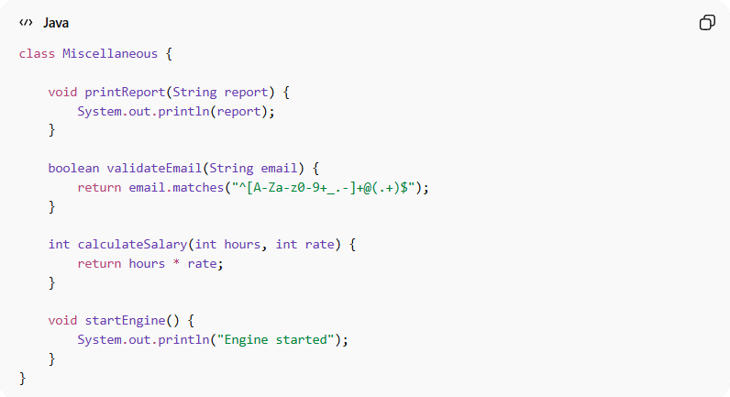
class Miscellaneous {

void printReport(String report) {
System.out.println(report);
}

boolean validateEmail(String email) {
return email.matches("^[A-Za-z0-9+_.-]+@(.+)$");
}

int calculateSalary(int hours, int rate) {
return hours * rate;
}

void startEngine() {
System.out.println("Engine started");
}
}
- ❌ Methods have no relation
- 🔴 Random combination → coincidental cohesion
- ⚠️ Very difficult to maintain or reuse

🛡️ Avoiding Coincidental Cohesion Example:
# Source: AI Source: Provided by: [Data Path: Persons Table -> ID Column: 1, Name_En Column: Motasem Essam] -> From: [Chatgpt (GPT‑5 Mini)] on [12/9/2025]
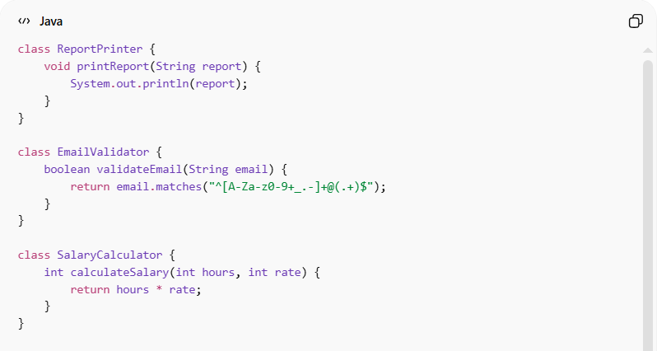
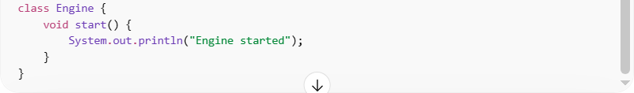
class ReportPrinter {
void printReport(String report) {
System.out.println(report);
}
}

class EmailValidator {
boolean validateEmail(String email) {
return email.matches("^[A-Za-z0-9+_.-]+@(.+)$");
}
}

class SalaryCalculator {
int calculateSalary(int hours, int rate) {
return hours * rate;
}
}

class Engine {
void start() {
System.out.println("Engine started");
}
}
Usage:
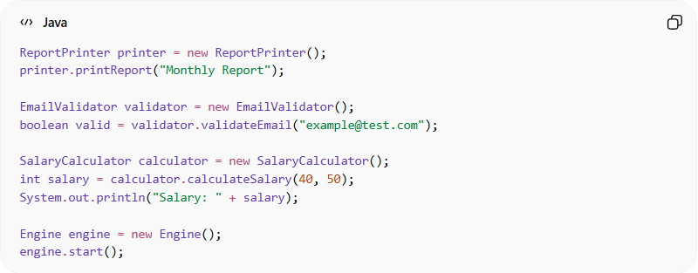
ReportPrinter printer = new ReportPrinter();
printer.printReport("Monthly Report");

EmailValidator validator = new EmailValidator();
boolean valid = validator.validateEmail("example@test.com");

SalaryCalculator calculator = new SalaryCalculator();
int salary = calculator.calculateSalary(40, 50);
System.out.println("Salary: " + salary);

Engine engine = new Engine();
engine.start();
✅ Key improvements:
- 🧩 Each class has a single responsibility
- 🔄 Methods are focused and cohesive
- ⚙️ Easier to maintain, test, and reuse
- 🔗 Eliminates “catch-all” class with unrelated methods

⚙️ Best Practice:
# Source: AI Source: Provided by: [Data Path: Persons Table -> ID Column: 1, Name_En Column: Motasem Essam] -> From: [Chatgpt (GPT‑5 Mini)] on [12/9/2025]
- Avoid grouping unrelated methods in one class
- Split into focused, single-purpose classes
- Follow Single Responsibility Principle (SRP)
- Aim for functional or communicational cohesion instead

If you want, I can also provide the 🛡️ Avoiding Coincidental Cohesion Example with proper modular design and usage, similar to the other cohesion examples.
Do you want me to do that next?

